**ADFS to Azure AD App Migration Tool Instructions**

The ADFS to AAD App Migration tool consists of three steps:

**Collect**

First, we collect the relying party applications from your ADFS server. This is done via a PowerShell module that will need to run on one of your ADFS server and it writes the configuration of each application to the file system as individual .XML files

**Analyze**

Next, our PowerShell module will enumerate through the individual .XML files and check the configuration of various settings. This analysis can be done directly on your ADFS server or can be done on another ADFS server but currently, it requires ADFS be installed to properly process the configuration.

**Report**

Lastly, we generate a final Excel report of your relying party applications that outlines which applications can be migrated to Azure AD and which ones can’t and why they can’t. This part has to be run from a workstation or server where Excel is installed.

**Collect & Analyze**

**Instructions if you want to collect and analyze directly from your ADFS server:**

1. Download PowerShell module from <http://aka.ms/migrateapps/adfsscript>

2.) Copy PowerShell module to one of your ADFS servers that you want to run analysis. If you need to save file, be sure to save as .psm1

3.) From this same ADFS server, open PowerShell as "Administrator"

4.) Change the directory to where you placed this PowerShell module

5.) From that PowerShell window, run the following:

ipmo .\ADFSAADMigrationUtils.psm1

Export-ADFS2AADOnPremConfiguration

Test-ADFS2AADOnPremRPTrustSet -RPXMLFileDirectory "C:\adfs\apps"

6.) Collect the following files from the ADFS server. They will be in the same folder that you changed directories to in Step 4.

* + ADFSRPConfiguration.csv
  + Attributes.csv
  + AttributeStores.csv
  + ClaimTypes.csv
  + RuleDetails.csv

7.) On a workstation that has Excel installed, create a folder at c:\adfs and place the above .csv files in this folder

8.) From this same workstation, open this Excel spreadsheet and navigate to the Dashboard tab and hit the Refresh Data button on the right.

**Note:** If you want to re-export and re-analyze the data, just repeat Steps 5-7 and overwrite files in Step 6 with new files

**Instructions If You Want to run the Analysis from Another Server**

**ADFS Server**

1. On your ADFS server, download PowerShell module from <http://aka.ms/migrateapps/adfsscript>. If you need to save file, be sure to save as .psm1.
2. From this same ADFS server, open PowerShell as "Administrator".

4.) Change the directory to where you placed this PowerShell module.

5.) From that PowerShell window, run the following:

ipmo .\ADFSAADMigrationUtils.psm1

Export-ADFS2AADOnPremConfiguration

**Run Analysis From Another Server**

1.) Copy c:\ADFS\ADFSApps.zip from your ADFS server to another ADFS server where you want to run analysis

2.) On this other ADFS server, unzip the .XML files to a folder of your choosing

3.) On this other ADFS server, download PowerShell module from <http://aka.ms/migrateapps/adfsscript>. If you need to save file, be sure to save as .psm1 .

4.) From this other server, open PowerShell as "Administrator".

5.) Change the directory to where you placed this PowerShell module.

6.) From that PowerShell window, run the following:

ipmo .\ADFSAADMigrationUtils.psm1

Test-ADFS2AADOnPremRPTrustSet -RPXMLFileDirectory "<Full Path to XML Folder>"

7.) Collect the following files from this ADFS server. They will be in the same folder that you changed directories to in Step 5.

* + ADFSRPConfiguration.csv
  + Attributes.csv
  + AttributeStores.csv
  + ClaimTypes.csv
  + RuleDetails.csv

8.) On a workstation that has Excel installed, create a folder at c:\adfs and place the above .csv files in this folder

9.) From this same workstation, open this Excel spreadsheet and navigate to the Dashboard tab and hit the Refresh Data button on the right.

**Note:** If you want to re-export and re-analyze the data, just repeat Steps 7-10 and overwrite files in Step 6 with new files.

**Report - Instructions for Using the Excel Spreadsheet**

**Refreshing Your Data**

Anytime you want to refresh your data, just make sure that the latest .csv files are located within c:\ADFS and from the Dashboard tab, just hit the ‘Refresh Data’ button:

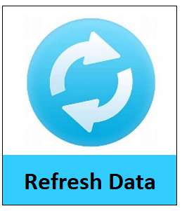

**Viewing Your All-Up Results**

The first tab you’ll want to review is the ‘Dashboard’ tab to see an all-up view of how many applications you have and whether they can migrate to Azure AD or not:

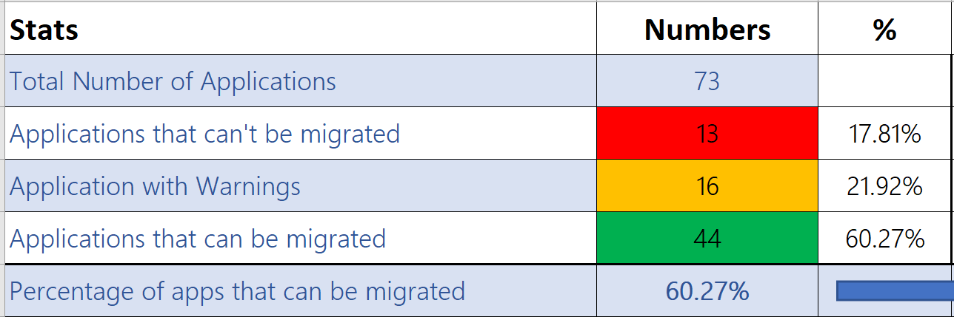

**Viewing Individual Application Results**

Next, you’ll want to look at the individual status on each application on the ‘AAD App Migration Report’ tab. This will tell you whether the application will readily migrate to Azure AD or whether there are settingd on the application that are currently incompatible with Azure AD or need to be reviewed further.

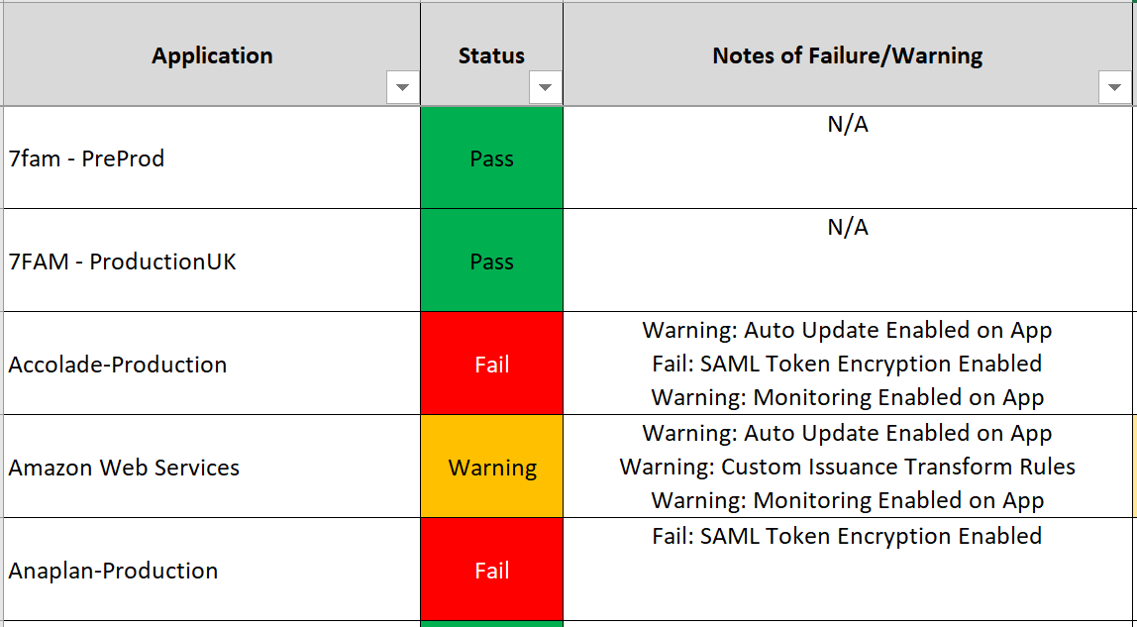

As you can see here, both 7FAM applications passed and can be readily migrate to Azure AD but the remaining three applications have some items on them that could prevent them from being moved to Azure AD.

**Note: See bottom of document for description of each result**

Additionally, from this same tab, we include the following items per application so you can gain some further insight about what configuration changes may be required to move your application to Azure AD:

* **Claim Rules to Review:** We flag any “custom” claim rules that may not be compatible with Azure AD and provide the total number of rules per application, so you can prioritize accordingly.
* **Attributes Not Synced to AAD by Default:** If any of the claim rules contains AD attributes that aren’t synced to Azure AD by default, we include this total count here.
* **Authorization Rules Present:** If your application has any authorization rules present, all this means is you’ll need to move these over to Azure AD Conditional Access.
* **Restricted Claim Types:** Azure AD doesn’t allow certain claim type URI’s to be modified so we include whether any of the claim rules contains any of these restricted claim type URI’s. This is more informational than anything.
* **Custom Attribute Stores:** Azure AD doesn’t currently support any custom attribute stores so if you’re using anything beyond ‘Active Directory’ within your claim rules, we give you that count here.

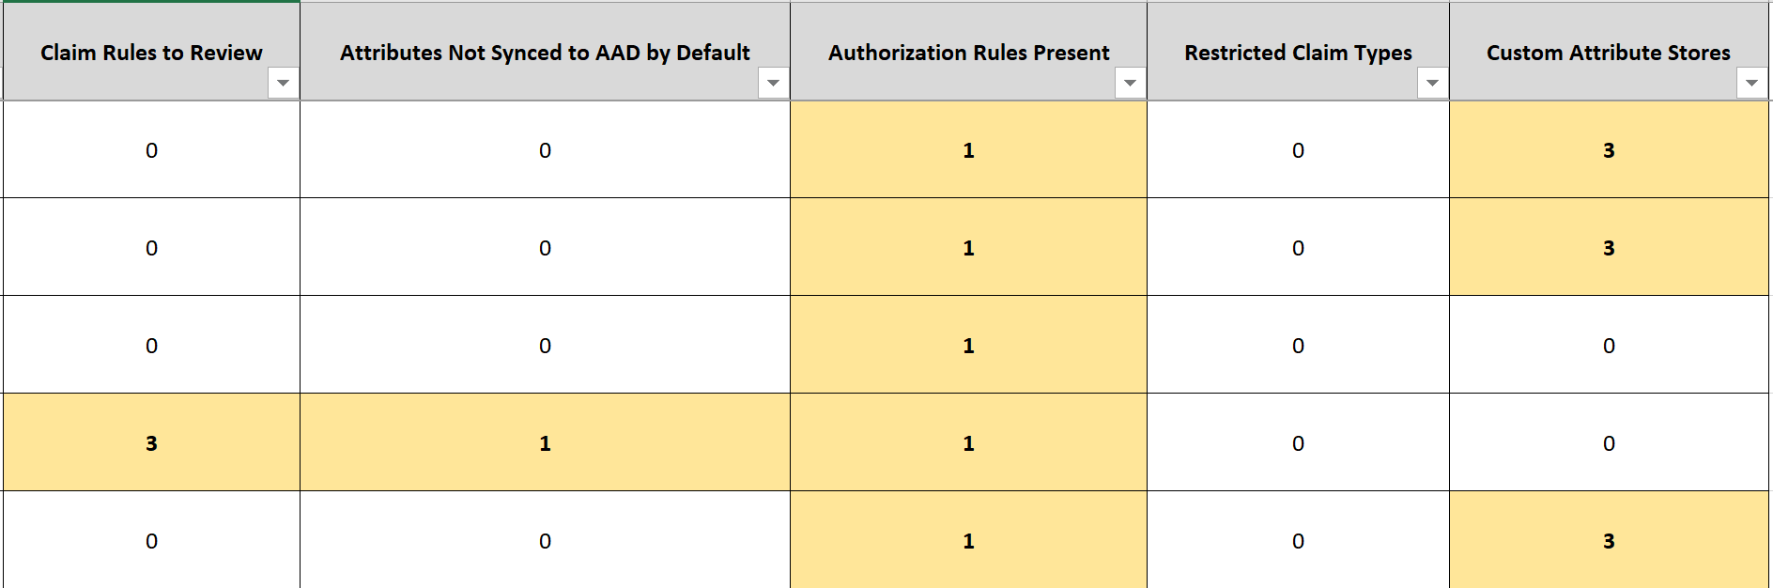

**Viewing All your Claim Rules**

If you want more detail on all your claim rules across all your applications, navigate to the ‘Claim Rules Details’ tab. This provides you with the following information:

* **RP Name:** The name of the application
* **Ruleset:** Whether claim rule is for issuance, authorization, delegation, or impersonation
* **Rule:** The entirety of the individual claim rule
* **IsRuleKnownMigrateablePattern:** Whether the rule can be readily migrated to Azure AD or not. Many rules may migrate with minor modifications.
* **KnownRulePatternName:** We run each rule through a series of checks to see whether it’s compatible with Azure AD. This is just the name of the rule that the claim rule matched. Only present if the rule passed.

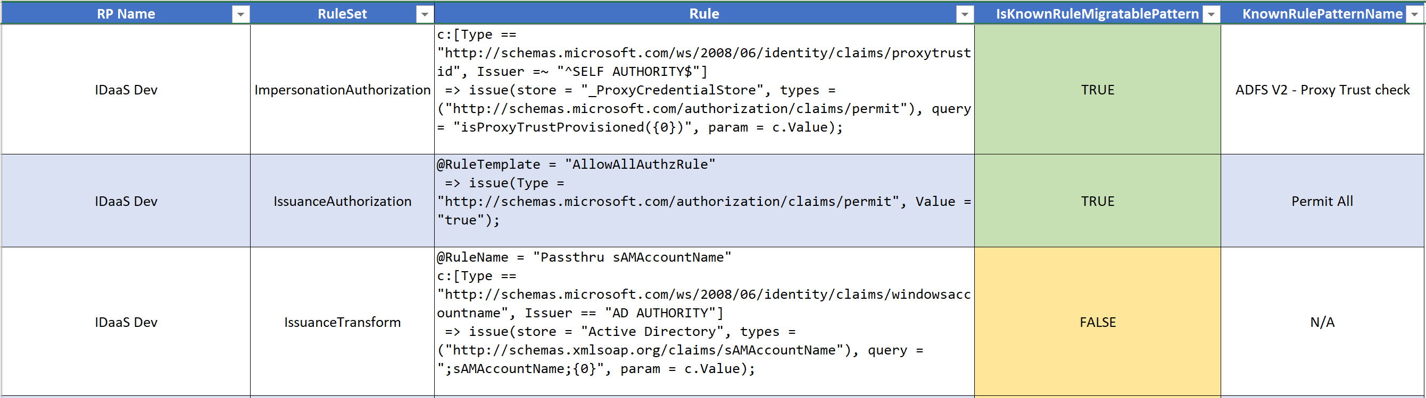

**Viewing All your AD Attributes within your Claim Rules**

If you want more detail on all the AD attributes in use across all your applications, navigate to the ‘AD Attributes’ tab. This provides you with the following information:

* **RP Name:** The name of the application
* **Ruleset:** Whether claim rule is for issuance, authorization, delegation, or impersonation
* **Rule:** The entirety of the individual claim rule
* **ADAttribute:** Actual AD attribute in use within the rule
* **Synced to Azure AD by Default:** By default, Azure AD Connect only syncs a finite list of attributes although it can be customized to sync more. You’ll want to ensure that any application you migrate to Azure AD has all the necessary AD attributes also being synced to Azure AD via Azure AD Connect.
* **Note:** We highlight (in red) where the AD attribute is in use within the claim rule.

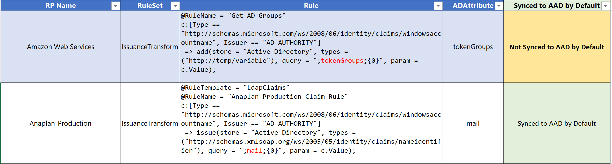

**Viewing All your Claim Type URI’s within your Claim Rules**

If you want more detail on all the individual claim types URI’s in use across all your applications, navigate to the ‘Claim Types’ tab. When moving an application to Azure AD, it easier to just register your individual claim types within Azure AD rather than asking your software vendor to change their configuration. This provides you with the following information:

* **RP Name:** The name of the application
* **Rule:** The entirety of the individual claim rule
* **Claim Type:** The claim type URI in use within that claim rule
* **Restricted Claim Type:** Azure AD doesn’t allow certain claim type URI’s to be modified so we include whether this specific claim type is restricted within Azure AD. This is more informational than anything.
* **Note:** We highlight (in red) where the Claim Type URI is in use within the claim rule.

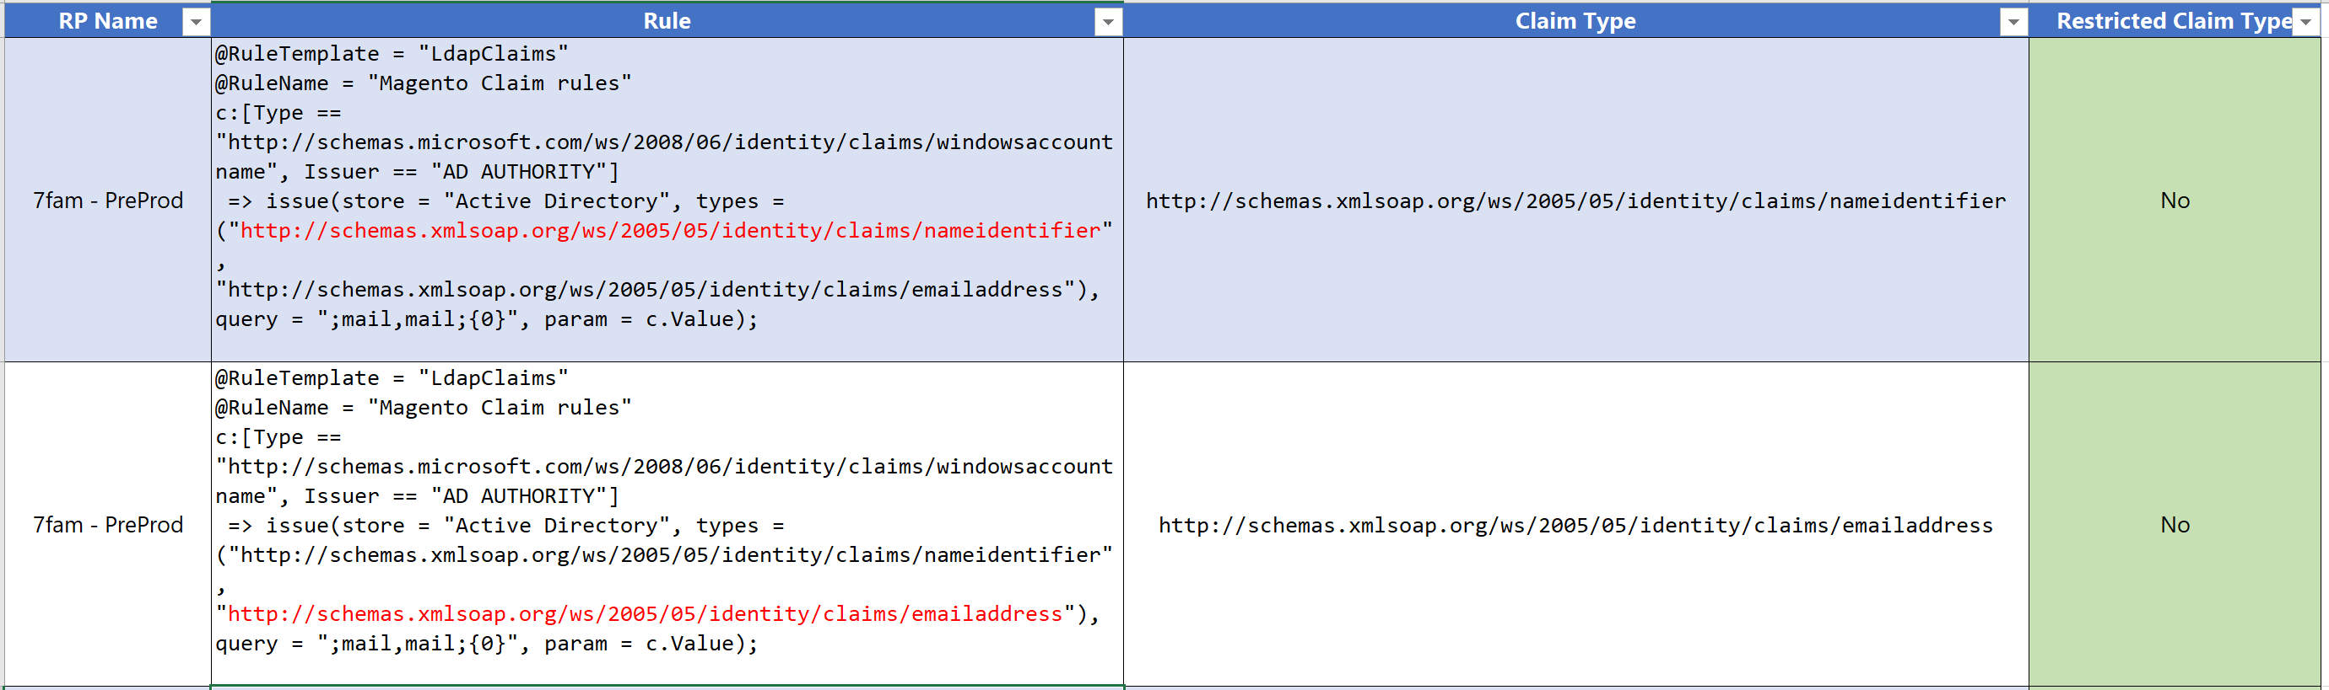

**Viewing All your Attribute Stores within your Claim Rules**

If you want more detail on all the Attribute Stores in use across all your applications, navigate to the ‘Attribute Stores’ tab. Azure AD doesn’t currently support any custom attribute stores. This provides you with the following information:

* **RP Name:** The name of the application
* **Rule:** The entirety of the individual claim rule
* **AttributeStoreName:** The name of the Attribute Store in use. We highlight any that aren’t ‘Active Directory’
* **Note:** We highlight (in red) where the Attribute Store is in use within the claim rule. Also, the _ProxyCredentialStore is an ADFS 2.0 concept that isn’t truly a blocker for moving an application to Azure AD.

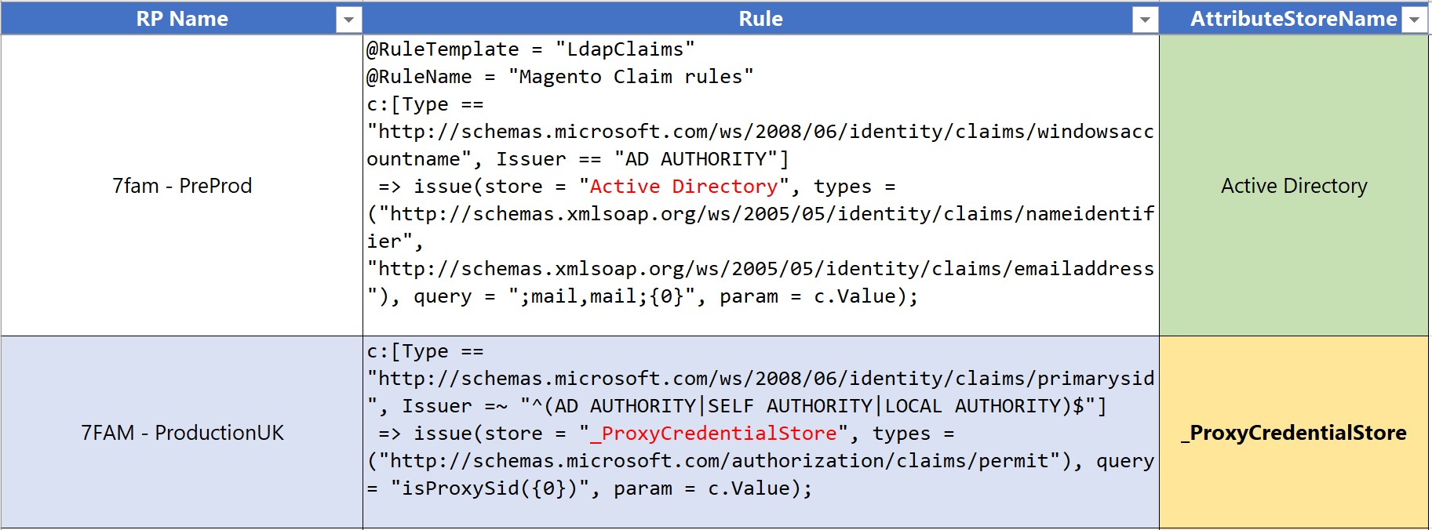

**Modeling Change to your applications**

We wanted to provide a way for customers to see the migration impact of changes they are willing to make to their applications without them actually having to make any changes. So back on the ‘Dashboard’ tab, you can type **Yes** next to the issues you’re willing to resolve and see how that impacts your migration %. Additionally, the issues impacting the most applications will highlight themselves in a light green like so:

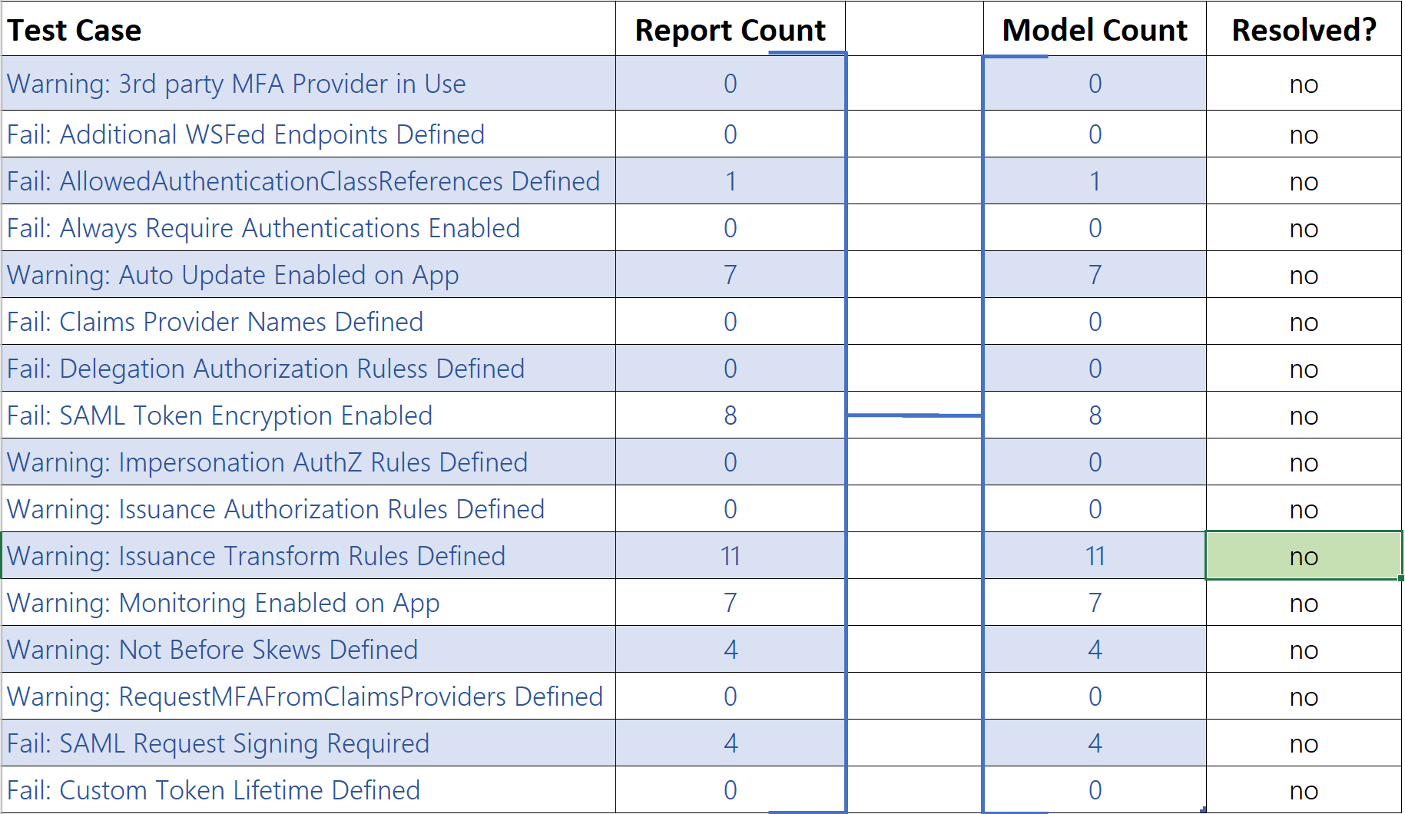

Next, mark the items you are committing to resolve or features that may be coming as part of the Azure AD roadmap:

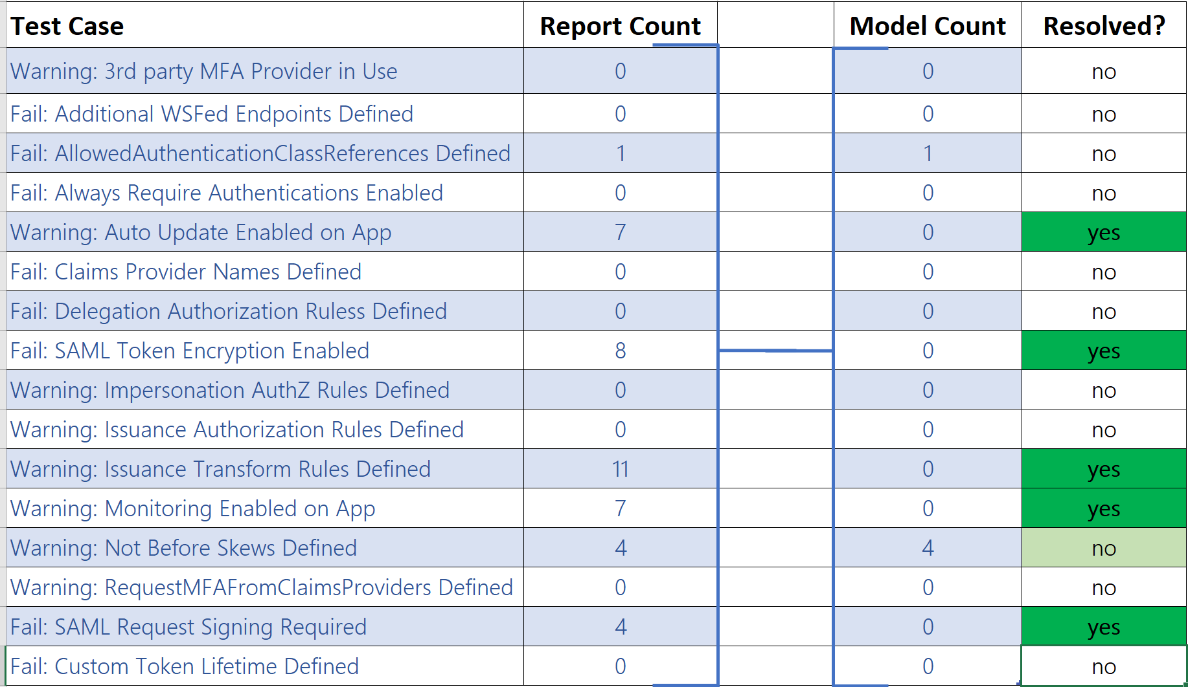

Upon doing so, the top of the ‘Dashboard’ tab will update to reflect your new migration % like so:

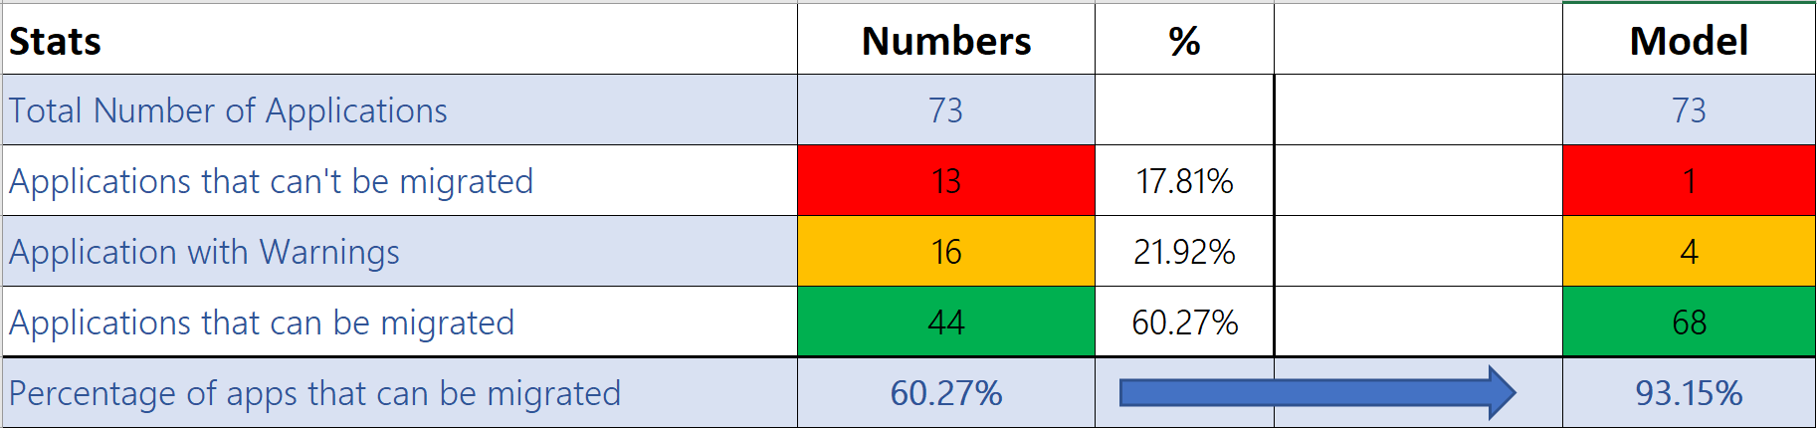

**Viewing All Tests we Ran Your Applications Through**

If you’re interested to see all the tests we ran your applications through with a status of Pass, Warning, or Fail, navigate to the ‘All Apps Details’ tab. Here is more information on each of the columns:

|  |  |  |
| --- | --- | --- |
| **Property** | **Status** | **Description** |
| RP Name | N/A | Friendly name of application |
| Result | Pass/Warning/Fail | All-up result for specific application. If application has any fails, result will default to fail. If application only has warning, result will default to warning. |
| Test-ADFSRPAdditionalAuthenticationRules | Pass/Warning | Testing for any on-premises MFA providers. Will need to be moved to Azure MFA or Custom Controls integration with 3rd party MFA provider. |
| Test-ADFSRPAdditionalWSFedEndpoint | Pass/Fail | Testing for multiple WS-Fed assertion endpoints since Azure AD only supports (1) one of these today. |
| Test-ADFSRPAllowedAuthenticationClassReferences | Pass/Fail | Whether the application is configured to only allow certain authentication types |
| Test-ADFSRPAlwaysRequireAuthentication | Pass/Fail | Whether the application is configured to ignore SSO cookies and ‘Always Prompt for Authentication’. Not supported by Azure AD today. |
| Test-ADFSRPAutoUpdateEnabled | Pass/Warning | Whether ADFS is configured to auto update the application based on changes within the federation metadata |
| Test-ADFSRPClaimsProviderName | Pass/Fail | Whether the application is hardcoded to another claim provider. Not supported by Azure AD today. |
| Test-ADFSRPDelegationAuthorizationRules | Pass/Fail | Whether the application has any custom delegation authorization rules defined. Azure AD does not support this today. |
| Test-ADFSRPEncryptClaims | Pass/Fail | Whether the application is configured for SAML Token Encryption. Azure AD does not support this today. |
| Test-ADFSRPImpersonationAuthorizationRules | Pass/Warning | Whether the application has any custom impersonation authorization rules defined. Azure AD does not support this today. |
| Test-ADFSRPIssuanceAuthorizationRules | Pass/Warning | Whether the application has any custom issuance authorization rules defined. Move to AAD CA |
| Test-ADFSRPIssuanceTransformRules | Pass/Warning | Whether the application has any custom issuance transform rules defined |
| Test-ADFSRPMonitoringEnabled | Pass/Warning | Whether ADFS is configured to monitor a federation metadata for this application. |
| Test-ADFSRPNotBeforeSkew | Pass/Warning | Whether ADFS allows a time skew based on the NotBefore and NotOnOrAfter times within SAML token. |
| Test-ADFSRPRequestMFAFromClaimsProviders | Pass/Warning | Whether the application is hardcoded to another claim provider and requires MFA. Not supported by Azure AD today. |
| Test-ADFSRPSignedSamlRequestsRequired | Pass/Fail | Whether the application is configured for SAML Request Signing. Azure AD does not support this today. |
| Test-ADFSRPTokenLifetime | Pass/Fail | Whether the application is configured for a custom token lifetime. ADFS default is 1 hour. |